**INTRODUCTION TO JAVASCRIPT**

**LAB # 10**



**Fall 2021**

**CSE101L Computer Fundamentals Lab**

Submitted by: **Ali Asghar**

Registration No. :21PWCSE2059

Class Section: **C**

“On my honor, as student of University of Engineering and Technology, I have neither given nor received unauthorized assistance on this academic work.”



Student Signature: ______________

Submitted to:

**Engr. Abdullah Hamid**

March 12, 2022

Department of Computer Systems Engineering

University of Engineering and Technology, Peshawar

**LAB TASKS**

**Task 1:**

Make a webpage according to the diagram in the image below

NOTE: This Lab task should be uploaded as an HTML FILE. The Picture(s) (if you have used any) should also be uploaded so that I could check it properly.

**CODE SCREENSHOT:**

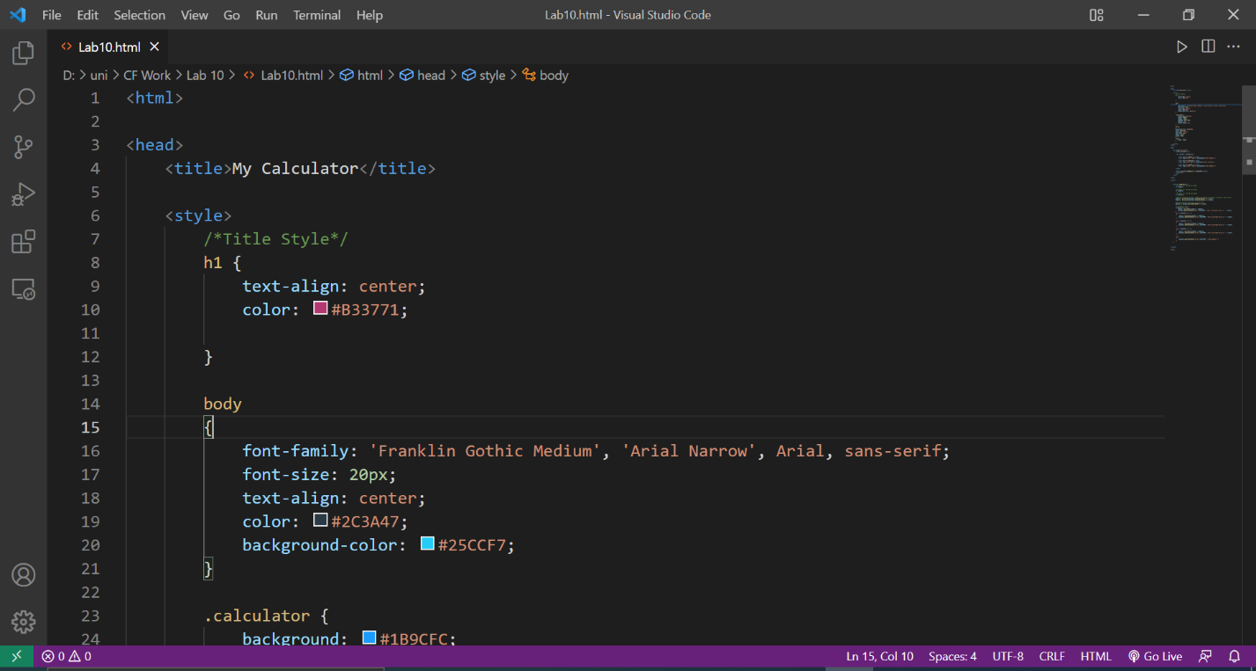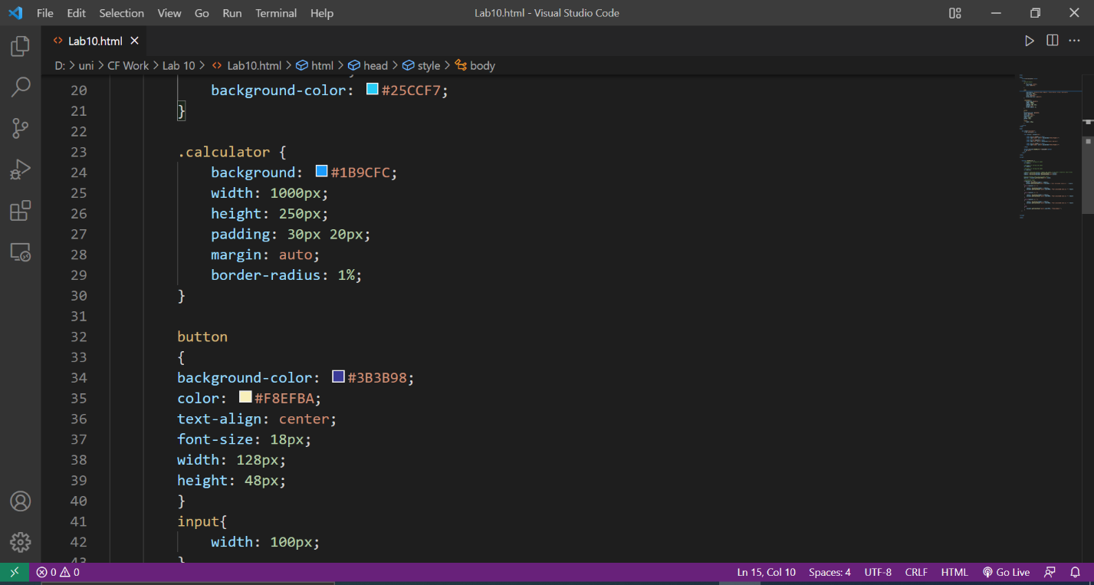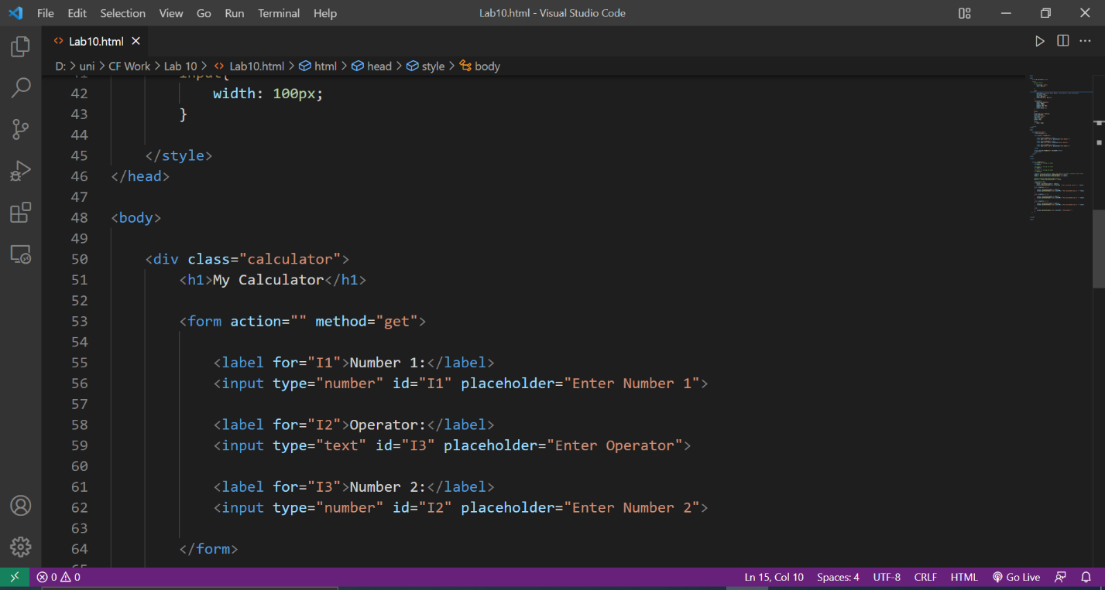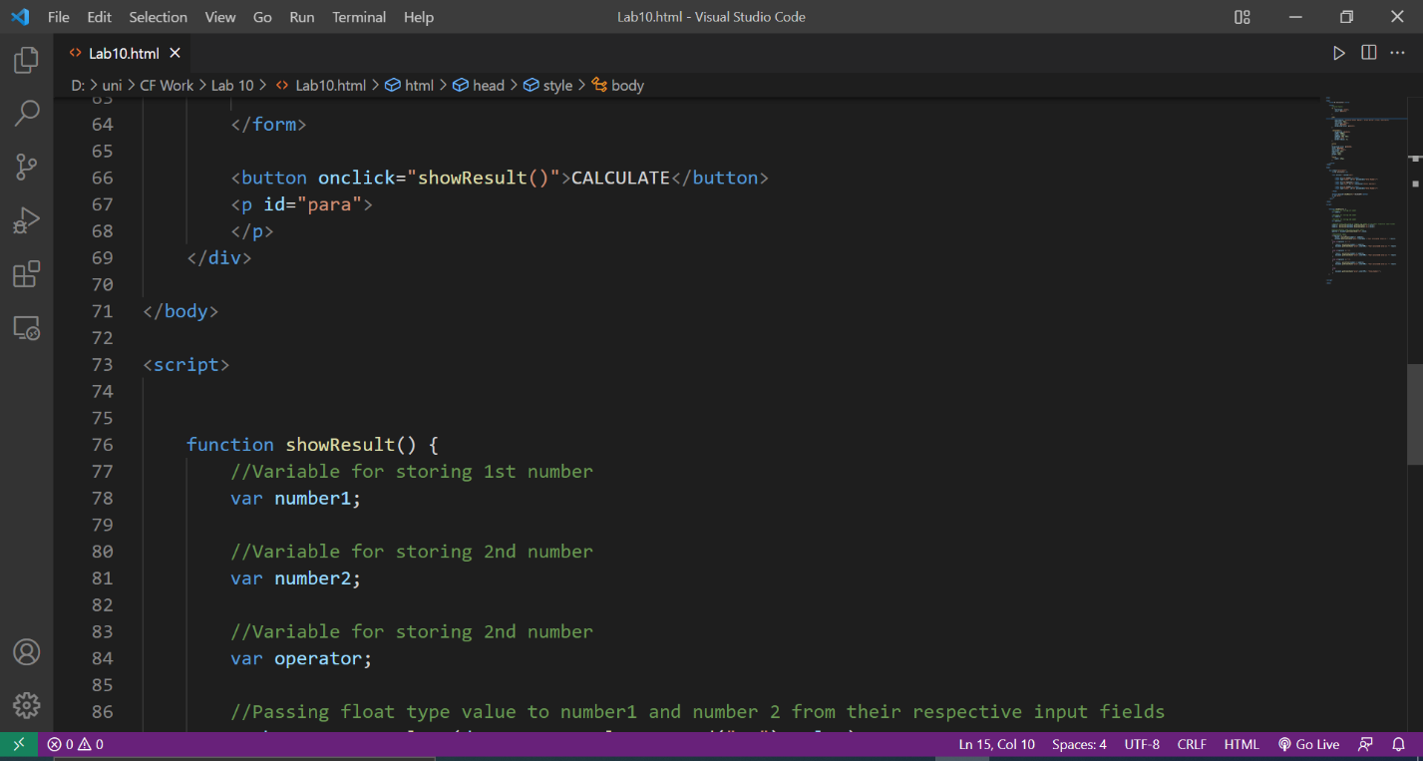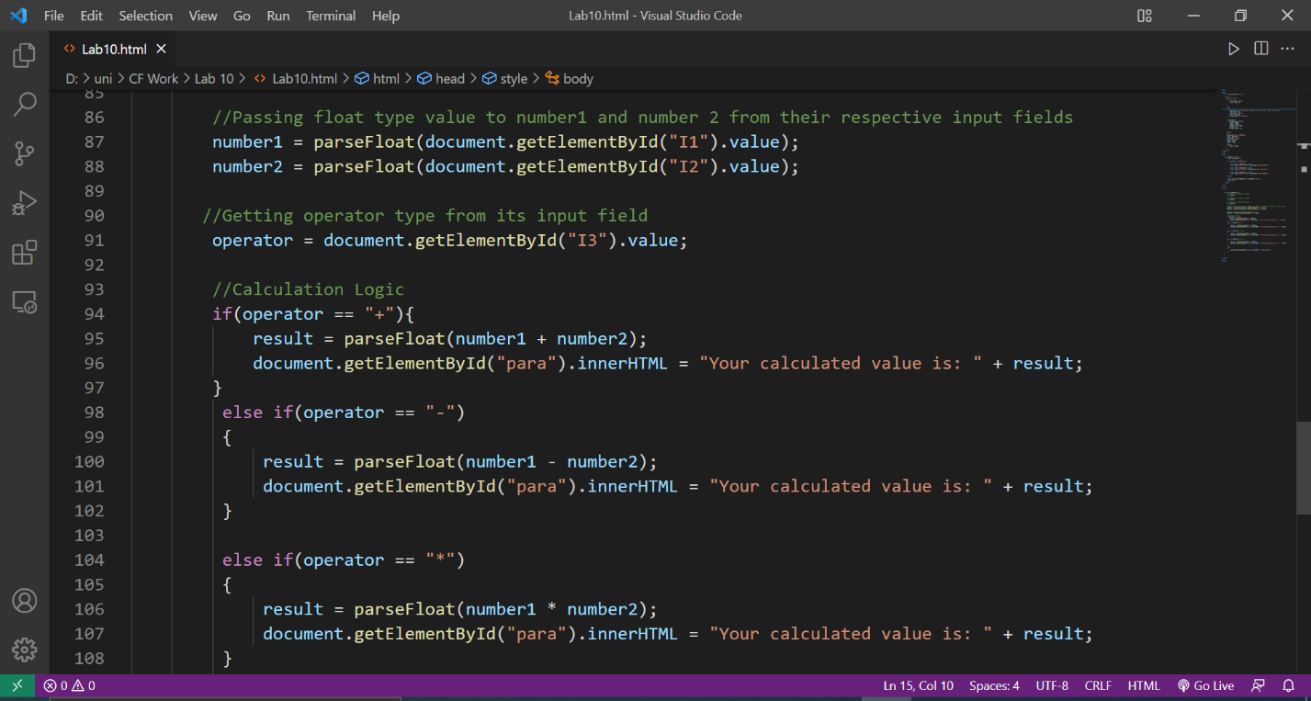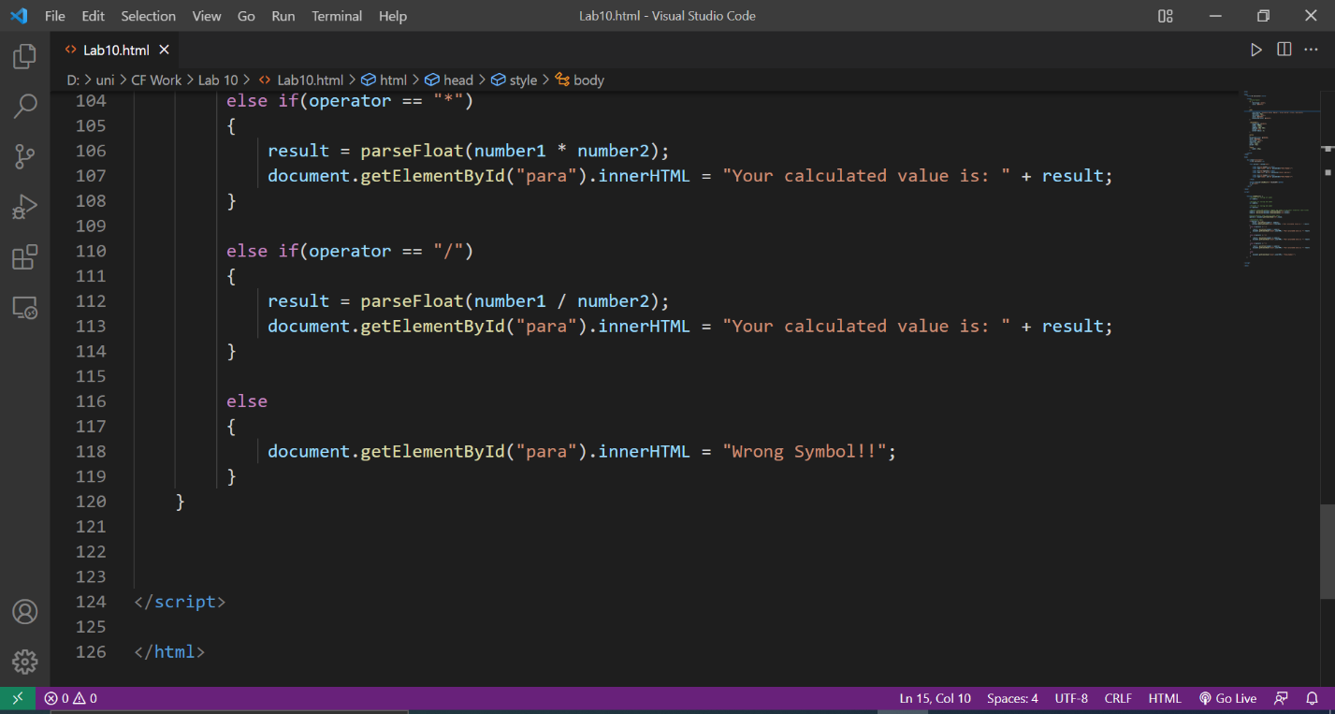

**OUTPUT:**

